UNITED STATES

SECURITIES AND EXCHANGE COMMISSION
Washington, D.C. 20549

SCHEDULE 14A

Proxy Statement Pursuant to Section 14(a) of the
Securities Exchange Act of 1934

(Amendment No. )

Filed by the Registrant ☒

Filed by a Party other than the Registrant ☐

Check the appropriate box:

- Preliminary Proxy Statement

- Confidential, for Use of the Commission Only (as permitted by Rule 14a-6(e)(2))

- Definitive Proxy Statement

- Definitive Additional Materials

- Soliciting Material Pursuant to § 240.14a-12

Orion Energy Systems, Inc.

(Name of Registrant as Specified in its Charter)

(Name of Person(s) Filing Proxy Statement, if other than the Registrant)

Payment of Filing Fee (Check the appropriate box):

- No fee required.

- Fee paid previously with preliminary materials.

- Fee computed on table in exhibit required by Item 25(b) per Exchange Act Rules 14a-6(i)(1) and 0-11

ORION ENERGY SYSTEMS, INC.

2210 WOODLAND DRIVE
MANITOWOC, WI 54220

T01310-P53443





Your Vote Counts!

ORION ENERGY SYSTEMS, INC.

2026 Annual Meeting

Vote by August 5, 2026

11:59 PM ET





You invested in ORION ENERGY SYSTEMS, INC. and it’s time to vote!

You have the right to vote on proposals being presented at the Annual Meeting. This is an important notice regarding the availability of proxy materials for the shareholder meeting to be held on August 6, 2026.

Get informed before you vote

View the Notice and Proxy Statement and Annual Report on Form 10-K online OR you can receive a free paper or email copy of the material(s) by requesting prior to July 23, 2026. If you would like to request a copy of the material(s) for this and/or future shareholder meetings, you may (1) visit www.ProxyVote.com, (2) call 1-800-579-1639 or (3) send an email to sendmaterial@proxyvote.com. If sending an email, please include your control number (indicated below) in the subject line. Unless requested, you will not otherwise receive a paper or email copy.
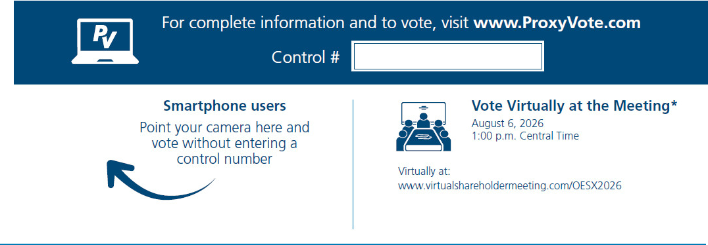

* Please check the meeting materials for any special requirements for meeting attendance.

Vote at www.ProxyVote.com

THIS IS NOT A VOTABLE BALLOT

This is an overview of the proposals being presented at the upcoming

shareholder meeting. Please follow the instructions on the reverse side to

vote these important matters.

 |  |  |  | Board
Voting Items |  |  |  | Recommends
1. |  | Election of Directors:
 |  | Nominees: |  | For
 |  | 01) | Richard A. Shapiro
 | 02) |  | Heather L. Wishart-Smith
2. |  | Advisory vote on the approval of the compensation of the Company’s named executive officers as disclosed in the proxy |  | For
 |  | statement. |  | For
3. |  | Ratification of BDO USA, P.C. to serve as the Company’s independent registered public accounting firm for fiscal year 2027. |  | For
4. |  | To approve the 2016 Orion Energy Systems, Inc. Omnibus Incentive Plan, as amended and restated. |  | For

NOTE: THE PROXY WHEN PROPERLY EXECUTED WILL BE VOTED AS DIRECTED OR, IF NO DIRECTION IS GIVEN, THE PROXY WILL BE VOTED FOR THE DIRECTOR NOMINEES INDICATED ABOVE AND FOR ITEMS 2, 3 AND 4. IT WILL ALSO BE VOTED IN ACCORDANCE WITH BEST JUDGMENT OF THE PROXIES NAMED HEREIN ON ANY OTHER BUSINESS THAT MAY PROPERLY COME BEFORE THE ANNUAL MEETING OR ANY ADJOURNMENT OR POSTPONEMENT THEREOF.

Prefer to receive an email instead? While voting on www.ProxyVote.com, be sure to click “Delivery Settings”.

T01311-P53443

